 | Revista Facultad de Ingeniería | 
Title: Levelized cost analysis in fixed-bottom offshore wind farms in the Colombian Caribbean


Authors: Jorge Mario Illidge-Araujo, Jorge Luis Chacón-Velasco, Manuel de Jesús Martínez and Carlos Jaime Barrios-Hernández

DOI: 10.17533/udea.redin.20251190

To appear in: Revista Facultad de Ingeniería Universidad de Antioquia

Received: September 17, 2024
Accepted: November 5, 2025
Available Online: November 5, 2025

This is the PDF version of an unedited article that has been peer-reviewed and accepted for publication. It is an early version, to our customers; however, the content is the same as the published article, but it does not have the final copy-editing, formatting, typesetting and other editing done by the publisher before the final published version. During this editing process, some errors might be discovered which could affect the content, besides all legal disclaimers that apply to this journal.

Please cite this article as: J. M. Illidge-Araujo, J. L. Chacón-Velasco, M. de J. Martínez, and C. J. Barrios-Hernández. Levelized cost analysis in fixed-bottom offshore wind farms in the Colombian Caribbean, Revista Facultad de Ingeniería Universidad de Antioquia, Nov. 2025 [Online]. Available: https://www.doi.org/10.17533/udea.redin.20251190

Levelized cost analysis in fixed-bottom offshore wind farms in the Colombian Caribbean
Análisis de costos nivelados en parques eólicos marinos de cimentación fija en el Caribe colombiano

Jorge Mario Illidge-Araujo^{1*} https://orcid.org/0009-0001-9955-7401 Jorge Luis Chacón-Velasco¹ https://orcid.org/0000-0001-9658-698X Manuel de Jesús Martínez¹ https://orcid.org/0000-0001-7069-6400 Carlos Jaime Barrios-Hernández² https://orcid.org/0000-0002-3227-8651

¹ Escuela de Ingeniería Mecánica, Grupo de investigación en energía y medio ambiente (GIEMA), Universidad Industrial de Santander. Carrera 27 Calle 9. C. P. 680002. Bucaramanga, Colombia

²Escuela de Ingeniería de sistemas e informática, Grupo de investigación de cómputo avanzado y a gran escala (CAGE), Universidad Industrial de Santander. Carrera 27 Calle 9. C. P. 680002. Bucaramanga, Colombia

Corresponding author: Jorge Mario Illidge-Araujo
E-mail: jorge2238089@correo.uis.edu.co

KEYWORDS
Offshore wind power, fixed bottom, renewable energy sources, levelized cost of energy, Colombian Coast
Energía eólica marina, cimentación fija, fuentes de energía renovable, costo nivelado de energía, Costa colombiana

ABSTRACT: The primary objective of this article is to estimate the levelized costs of fixed-bottom offshore wind energy in the Colombian Caribbean, particularly in the vicinity of La Guajira. Based on a review of existing literature, various mathematical models are evaluated to calculate the production costs of offshore wind projects, using a base case reported by the National Renewable Energy Laboratory in the United States. The goal is to identify the model that most accurately reflects the costs estimated by other global entities. The production costs are calculated for areas designated by Colombia's Ministry of Mines and Energy as suitable for offshore wind energy generation. These areas, located in the Alta Guajira region, feature water depths of less than 50 meters. The levelized energy costs are found to range between 88 and 131 USD/MWh for capacity factors exceeding 54%. These capacity factors are higher than those typically recorded worldwide, which range from 33% to 50%. Additionally, part of the range of levelized energy costs obtained falls within the global range, which is from 49 to 155 USD/MWh.

RESUMEN: El principal objetivo de este artículo es estimar los costos nivelados de la energía eólica marina de cimentación fija en el Caribe colombiano, específicamente en los alrededores de La Guajira. Partiendo de información consultada en la literatura, se evalúan modelos matemáticos para el cálculo de los costos de producción de proyectos eólicos marinos con respecto a un caso base reportado por el Laboratorio Nacional de Energías Renovables de Estados Unidos. El objetivo es determinar el modelo que mejor se asemeje a los costos estimados en la literatura y por entidades a nivel mundial. Posteriormente, se calculan los costos de producción en las áreas definidas por el Ministerio de Minas y Energía de Colombia como aptas para la generación de energía eólica marina en los alrededores de la Alta Guajira, con profundidades menores a los 50 metros. Los costos nivelados de energía oscilan entre los 88 y 131 USD/MWh para factores de capacidad superiores al 54%, siendo estos factores superiores a los registrados a nivel mundial que varían entre el 33% y 50%. Asimismo, parte del rango de los costos nivelados de energía obtenidos se encuentran dentro del rango registrado a nivel mundial, que varía entre los 49 y los 155 USD/MWh.

Nomenclature
Latin and Greek symbols
m, Meters
km, Kilometers
${km}^{2}$, Square kilometers
${mm}^{2}$, Square millimeters
$C_{AR},$ Wind turbine costs
$C_{AR-mat},$ Wind turbine acquisition costs
$C_{AR-trans},$ Wind turbine transportation costs
$PR,$ Wind turbine power rating
$C_{ES},$ Foundation costs
$C_{ES-mat},$ Foundation acquisition costs
$C_{ES-trans},$ Foundation transportation costs
$Z,$ Water depth
$ha,$ Hub height
$d,$ Rotor diameter
$C_{IA},$ Collector system costs (Acquisition)
$C_{II},$ Collector system costs (Installation)
$L_{c},$ Total cable length of the collector system
$As,$ Cable cross-sectional area
$N,$ Number of wind turbines
$C_{suboff},$ Offshore substation cost
$C_{subon},$ Onshore substation cost
$CA,$ Installed power of the wind farm
$C_{EMA},$ Offshore export cable costs (Acquisition)
$C_{EMI},$ Offshore export cable costs (Installation)
$L_{eo},$ Offshore export cable length
$C_{ETA},$ Onshore export cable costs (Acquisition)
$C_{ETI},$ Onshore export cable costs (Installation)
$L_{en},$ Onshore export cable length
T, Years of operation of the wind farm

Abbreviations
IRENA, International Renewable Energy Agency
NREL, National Renewable Energy Laboratory
IEA, International Energy Agency
TRL Technology Readiness Level
W, Watts
kW, Kilowatts
MW, Megawatts
GW, Gigawatts
NPV, Net Present Value
LCOE, Levelized Cost of Energy
CAPEX, Capital Expenditure
OPEX, Operational Expenditure
MWh, Megawatts per hour
$AEP,$ Annual Energy Production
USD, American dollars
RPM, Revolutions per minute
DANE, National Administrative Department of Statistics
IPC, Consumer’s Price Index
WACC, Weighted Average Cost of Capital
FNCE, Non-conventional Sources of Energy

- Introduction
According to a publication by the Ministry of Mines and Energy of Colombia [1], wind energy is classified into two main types: fixed-bottom and floating structures. Fixed-bottom wind turbines are anchored to the ocean floor, while floating structures are not. According to a publication by the International Renewable Energy Agency (IRENA) [2], as of the end of 2023, offshore wind farms had an installed capacity of 74 GW. This capacity increased to 82 GW by the end of 2024.
According to the latest IRENA report [2], China and the United Kingdom are the leading countries in offshore wind farm installations, with nearly 41 GW and 15 GW installed, respectively, by the end of 2024. In contrast, the United States reported an installation of 171 MW during the same period. It is worth noting that Colombia is not among the countries that have installed offshore wind farms.
Wind turbines installed at sea produce more electricity than those on land, primarily due to the faster wind speeds offshore. As a result, offshore wind farms have a higher wind resource utilization factor, also known as the capacity factor, which refers to the amount of energy that a wind turbine can generate compared to the available wind potential in the area, than onshore wind farms, according to a publication by the Ministry of Mines and Energy of Colombia [1]. Furthermore, offshore wind farms have a lower visual and acoustic impact on the environment than their onshore counterparts, allowing for installation over larger areas to generate greater energy capacities, as noted in the publications by Hall [3] and Gonzalez-Rodriguez [4].
Maritime transport provides a clear advantage over land transport, as it is not subject to the same road limitations when reaching a destination. Furthermore, larger loads can be accommodated, enabling the installation of wind turbines capable of generating higher energy levels and larger sizes than those that can be installed on land, as stated in the IRENA publication [5].

- State of the art
The Ministry of Mines and Energy in Colombia recently published a report [1] on the country's potential for offshore wind energy. The report identified three zones with varying wind speeds and specified areas within these zones that are suitable for the installation of offshore wind farms. These selected areas have been thoroughly reviewed to ensure that they do not conflict with restricted spaces, maritime transportation routes, fishing activities, energy transmission lines, or oil and gas exploration zones. Figure 1 illustrates the defined zones and areas in the Colombian Caribbean Sea.

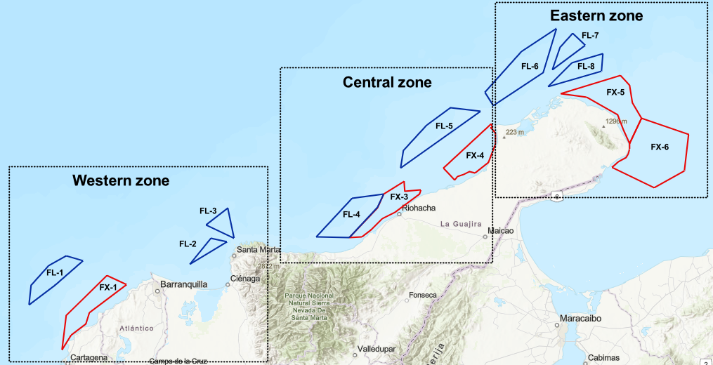
Figure 1. Zones and areas defined in the Colombian Caribbean Sea [1].

The Ministry's report [1] provides detailed information on wind turbines, including their depths, distances to the coast, and the type of support structure. The support structure is categorized into two kinds, namely fixed and floating. For installations with fixed support, there are five defined areas covering a total of 6,800 km² with a wind potential of approximately 27,200 MW. For installations with floating support, there are eight defined areas covering a total of 5,400 km² with a wind potential of around 21,600 MW. The capacity varies between approximately 37.5% and 69.5% for the 50th percentile.
The costs of offshore wind projects highly depend on their capacity factor, water depth, and distance from the coast. These parameters determine the number of wind turbines required to meet the project's energy needs, as well as the support structure and length of the energy export cable needed, as noted in publications by Stehly [6] and Liang [7].
In 2024, according to data published by IRENA [5], the global levelized cost (LCOE) of offshore wind energy ranged from 49 to 155 USD/MWh. The capital costs, or capital expenditures (CAPEX), were reported to be between 1,400 and 6,000 USD/kW, and the operational expenditures (OPEX) were reported to be between 76 and 121 USD/kW per year, all of costs being reported for the 5th and 95th percentiles.
According to Stehly [6], the CAPEX of an offshore wind project utilizing a fixed support structure is dominated by the wind turbine, which accounts for approximately 30–40% of the total cost. The support structure itself contributes around 14–20%. The impact of the energy transmission system on CAPEX varies depending on the distance to the coast and the installed generation capacity, with this contribution ranging between 10% and 20%.
Percentages ranging from 20% to 40% have been reported for the energy transmission system in reports such as [8]. The complete breakdown of the CAPEX for a wind project is generally divided into three parts: the costs of the wind turbines, the plant balance, and administrative expenses, as shown in [6]. Other authors categorize it into administrative costs, acquisition and production expenses, and installation and transportation expenses, as shown in the publications of Alsubal [9] and Cali [10]. These values vary significantly depending on the bathymetry conditions, distance to the coast, and installed generation capacity, as noted by Lozer [11] and Yuri [12].
The report titled "Colombia Offshore Wind Workshops," published by the Colombian Ministry of Mines and Energy in collaboration with the World Bank Group [13], outlines the current status of the processes leading to the implementation of an offshore wind farm in Colombia. The development and administrative processes are estimated to take approximately three to eight years, followed by a three-year construction period, and the wind farm is expected to operate for around 25 years.
The document [13] also discusses Colombia's port infrastructure, highlighting the development needs in various aspects of the industry and offering a comparison with global scenarios. Additionally, it provides a breakdown of the CAPEX for an offshore wind project. The breakdown is as follows: 9% for the development phase, 48% for the wind turbine, 24% for the support structure, 4% for the interconnection between wind turbines, 5% for the offshore substation, 6% for the marine export cable, 1% for the onshore transmission cable, and 3% for the onshore substation. This analysis reveals that, like projects in other countries, most of the investment is associated with the wind turbine in fixed-foundation offshore wind installations.
Several universities in Colombia have contributed to the study of renewable energy integration in the country. Notable publications include one by Garcia [14], which estimates the performance of various aerodynamic profiles under high mountain wind conditions in Colombia. Another significant work is by Rosero [15], who conducted CFD (computational fluid dynamics) simulations to optimize the geometry of different aerodynamic profiles for wind speeds in high-altitude regions.
Carmo [16] examines the incorporation of renewable energy into the country's sustainable supply chains, highlighting significant aspects of current research approaches and the modifications made to these supply chains. Another essential publication by Sosapanta [17], who explores solutions based on isolated microgrids for remote areas of Colombia, accompanied by a cost analysis of various alternative solutions.
Pineda [18] examines the wind potential available in the Gulf of Urabá, Colombia, finding that this potential accounts for approximately 9% of the country's energy demand. Another noteworthy publication is by Saxena [19], who explores potential improvements to Colombia's power generation and distribution networks to facilitate the integration of renewable energy. He suggests that distributed generation is one of the most effective options for adapting the country's distribution networks to accommodate energy from renewable sources.
Illidge [20] examines the performance of pico-hydro systems in rural areas of Colombia. A computational fluid dynamics simulation of a hydraulic turbine was conducted based on a power requirement outlined in a publication from ANSYS magazine. Another noteworthy study is that of Mesa [21], which investigates the impact of renewable energy on voltage stability in power transmission networks across Colombia. This research highlights both the advantages and disadvantages of integrating energy flows from renewable sources.

- Methodology
To calculate the LCOE, the Colombian Ministry of Mines and Energy [1] provided information on areas with the highest potential along the Colombian Caribbean coast. The eastern region, particularly around the Alta Guajira, is identified as having the highest wind speeds. For heights between 100 and 150 meters, wind speeds exceed 10 m/s during the first eight months of the year. In the last four months, the wind speed decreases to just over 6 m/s, but then rises to 10 m/s again in the twelfth month. Figure 2 shows the wind velocity over the year.

Figure 2. Wind velocity over the year for each zone in the Colombian Caribbean Sea [1].

According to the published data in Colombia's offshore wind energy roadmap [1], it is estimated that the capacity factor, for the 50th percentile, which describes a power generation scenario that includes the technical losses related to operating the offshore wind farm, can be achieved between 67.5% and 69.5% for the eastern zone. This is an advantage for offshore wind farms, as it increases efficiency and reduces production costs, as explained later.
The production costs for the eastern area were calculated based on the arguments presented earlier. To do this, two areas suitable for installations with fixed foundations were defined in the Alta Guajira region. These areas, with depths of less than 50 meters, are referred to as Area 1 and Area 2, also known as blocks FX-5 and FX-6 in the ministry report [1], and are illustrated in Figure 1.
Fixed foundation wind technology is a fully commercial product with a Technology Readiness Level (TRL) of 9 globally, as reported by Díaz-Motta [22]. There are currently installed and operating projects, as shown in the publications by IRENA [2], Stehly [6], and Díaz-Motta [22]. On the other hand, floating structure wind technology has a TRL between 8 and 9, meaning that it is not yet considered a fully developed technology, as shown in the publications of Díaz-Motta [22], Chitteth [23], and Martinez [24].
The next step involved defining the bathymetry conditions and the distance to the coast for the two selected areas used to calculate the levelized cost of energy. According to data published by the Ministry [1], the distance to the coast for Area 1 ranges from 10 to 25 kilometers, while for Area 2, it ranges from 10 to 45 kilometers.
The bathymetry data for both areas indicated that the depth ranges from 10 to 100 meters, as reported by the Ministry [1]. However, since fixed foundation wind technology is recommended for areas with depths of 50 meters or less, a depth range of 10 to 50 meters was assumed in accordance with the works of Kreider [25], Santhakumar [26], and Jiang [27]..
According to data collected by IRENA [5] and references such as Stehly [6] and Bilgili [28], a proposal has been made to establish a wind farm with an installed capacity of 800 MW in two specific areas. According to the publication by Ohunakin [29], a list of commercially available offshore wind turbines is provided, highlighting the most commonly used models in existing offshore wind farms around the world. It also includes those wind turbines that have been most frequently referenced in various studies of wind farms operating under similar capacity factor conditions. Additionally, the publication discusses recent projections for the introduction of new wind turbines in the offshore wind market. Seven wind turbines were evaluated, including the V236-15 MW turbine from Vestas. This turbine has the capacity to generate up to 15 MW of power, currently making it the highest-capacity wind turbine available, as noted in the publications by Bilgili [30], Arce [31], and Soares [32].
It should be noted that there are numerous wind turbines referenced worldwide that could yield different results. Future research could involve a performance study of various wind turbines under specific zone wind speed conditions, incorporating probability distributions, such as the Weibull distribution, along with the power and speed curves of each turbine to determine which turbine achieves the highest capacity factor in the given area, as shown in the publications by Lozer [11], Ozato [12], and Gil Ruiz [33]. However, for the present study, we are assuming the range of capacity factor values estimated by the Ministry of Mines and Energy of Colombia.
The wake effect in wind installations refers to the energy losses that occur due to the turbulence created behind wind turbines as the wind passes through them. This turbulence reduces wind speed, leading to downstream wind turbines receiving wind with less velocity and, consequently, generating less electricity, as demonstrated in the publication by Sun [34].
Based on extensive analyses and experiences from assembling various wind farms worldwide, it is recommended to maintain specific distances related to the diameter of the wind turbines. This practice helps to minimize the impact of the wake effect on energy generation. The recommended distances typically range from 7 to 10 times the diameter of the wind turbine in the direction of the prevailing wind, and the distances should be between 3 and 5 times the diameter of the wind turbine in the direction perpendicular to the dominant wind direction. Following these guidelines is estimated to result in wake losses ranging from 5% to 15%, as demonstrated by Lozer [11], Lee [35], and Yue [36].
The offshore wind turbines will be spaced apart based on specific guidelines: they will be separated by a distance equal to 10 times the diameter of the wind turbine rotor in the direction of the dominant wind, and 5 times the diameter of the rotor in a perpendicular direction. These guidelines refer to the works by Lozer [11], Lee [35], and Yue [36].
Wind turbines with power outputs ranging from 8 to 15 MW were examined by Ohunakin [20] and other authors, while Lozer [11] focused on a 10 MW wind turbine. Table 1 contains the parameters for the seven wind turbines selected for analysis. These wind turbines were chosen to evaluate the levelized cost of energy in the areas of interest.

Table 1. Defined wind turbine parameters.
Wind turbine | Power rating (MW) | Diameter (m) | Hub height (m)
V164-9.5 MW [29] | 9.5 | 164 | 140
V164-10 MW [29] | 10 | 164 | 140
V236-15 MW [29],[37] | 15 | 236 | 140
V164-8 MW [38] | 8 | 164 | 140
SG8,0-167 D [39] | 8 | 167 | 140
HX-12 MW [38] | 12 | 218 | 140
NREL-10 MW [11] | 10 | 205 | 140

To estimate the expenses associated with wind turbines and their support structures with fixed foundations, a comparative analysis was conducted. This analysis compared various mathematical models against the costs presented in a base case conducted by the National Renewable Energy Laboratory (NREL) for fixed foundation installations [6]. A total of five models were analyzed, corresponding to the works cited below.
In the article presented by Shafiee [27], several mathematical models were proposed to estimate the CAPEX for a 600 MW offshore wind installation. Each component contributing to this expenditure is expressed as a percentage of the total CAPEX. The cost of wind turbines is estimated based on their power output. To determine the price of the jacket-type support structure, a formula is proposed that considers the height of the axis, the diameter of the rotor, the wind turbine's power, and the site's depth. Furthermore, additional expressions are provided to estimate the costs associated with the energy transmission system.
Dicorato [40] presents various mathematical models for estimating the CAPEX of a 150 MW offshore wind project. The cost of wind turbines is estimated based on their power output. Three different expressions for calculating the cost of support structures are proposed: two are based on water depth, while the third considers the height of the hub, the diameter of the rotor, the power of the wind turbine, and the depth at the site. Additionally, the article provides formulas for estimating the costs of energy transmission systems.
Yildirim [41] offers mathematical models to estimate the CAPEX of offshore wind installations, similar to the models discussed by the two authors mentioned earlier. For the energy transmission system, a specific value is calculated based on the site conditions.
Ozato [12] presents mathematical models for estimating the CAPEX of an offshore wind installation. The cost of the wind turbines is calculated based on their installed capacity, while the price of the support structure is determined by both the water depth and the installed capacity.
Lozer [11] presents mathematical models for estimating the CAPEX of a 300 MW offshore wind installation. The cost of the wind turbines is calculated based on their installed capacity, while the price of the support structure is determined by both the water depth and the installed capacity. Furthermore, the costs associated with the energy transmission system are divided into three components: the interconnection between wind turbines, the submarine export cable, and the ground transmission cable. Formulas for calculating the cost of each element are provided, considering cable lengths and cross-sectional areas.
Expressions such as those presented by the abovementioned authors are used by Cali [10], who features different configurations of the energy transmission system.
Ohunakin [29] offers a comprehensive analysis of the costs associated with different wind turbines. Linag [7] discusses the various expenses related to support structures, while Alsubal [9] provides a detailed breakdown of capital expenditures. Additionally, Sim [8] examines the changes in net present value (NPV) over time, along with the associated installation costs.
A comparison was made between the NREL base case [6] and other models to identify those with the least deviation from the reference base case. The selected models are listed in Table 2.

Table 2. Results of the comparative analysis of mathematical models.
Component | M. Dicorato [40] | A. Yildirim [41] | Y. Ozato [12] | M. Shafiee [42] | M. Lozer [11] | U. Cali [10] | NREL Case  (USD2024/kW)
Wind turbine | 52% < NREL | 97% < NREL | 58% < NREL | 59% < NREL | 99% < NREL | 52% < NREL | 1823
Foundation | 88% > NREL | 14% < NREL | 10% > NREL | 73% > NREL | 11% > NREL | 87% > NREL | 787

Table 2 demonstrates that all expressions used to estimate the cost of the wind turbine are lower than the value obtained in the NREL base case. Although these expressions present reduced values compared to the NREL base case, when the complete models proposed by each author are utilized, the final CAPEX aligns more closely with values given by global entities. This is because the models tend to overestimate the cost of the support structure, which compensates for the lower estimated costs of the wind turbine itself. Notably, the expression that produced a price closest to the reference case was the one proposed by Dicorato [40]. Therefore, this expression was selected for calculating the costs of the wind turbines discussed in this article.
Additionally, Table 2 shows that the cost estimates for the support structure that were closest to the reference case were those presented by Yildirim [41], which yielded a value below the base case, and by Lozer [11], which produced a value slightly above the reference value. According to recent publications by NREL regarding the costs associated with offshore wind farms, it is evident that the costs of support structures are increasing year after year due to inflation and various industrial conditions, as documented in NREL publications [43], [44], and [6].
As a result, the expression proposed by Yildirim [41] was chosen for calculating the cost of the support structure. It is essential to apply the installation and transportation factor indicated in Yildirim [41] and other references to estimate the total cost of this component accurately. When the transportation and installation factor is applied to the different expressions, the resulting values are more than 50% higher than the base case value. In contrast, Yildirim's model yields values that are less than 30% above the base case and align with the annual increases in this component documented in NREL publications. Thus, it concludes that the best option for estimating the cost of the support structure is the expression proposed by Yildirim.
Accordingly, the model related to the top three bibliographic references —Dicorato [40], Yildirim [41], and Lozer [11] — for the costs of wind turbines, support structures, and energy transmission systems in the wind farm, is presented below. All costs are expressed in 2024 USD.

- Wind turbine costs
Dicorato [40] proposes a mathematical expression for calculating the cost of wind turbines ($C_{AR}$), which uses the nominal capacity for a single wind turbine ($PR$) of the wind farm as an input parameter, as shown in Equation 2. It is essential to clarify that nominal power should be expressed in megawatts, and the variable ($N$) refers to the number of wind turbines. It is assumed that the transportation and installation costs amount to 10% of the total cost of the wind turbines, based on recommendations found in Dicorato [40], Yildirim [41], and Lozer [11], as shown in Equation 3.
$$C_{AR}= \left(C_{AR-mat}+C_{AR-trans}\right)*N \left[USD\right]$$ | (1)
$$C_{AR-mat}=\left(\left({2,95*10}^{3}*\ln\left(PR\right)\right)-375,2\right)*1,38*1.000 \left[\frac{USD}{turbine}\right]$$ | (2)
$$C_{AR-trans}=10\text{\%}*C_{AR} \left[USD\right]$$ | (3)

- Foundations costs
Yildirim [41] proposes a mathematical expression for calculating the cost of the support structure ($C_{ES}$), as shown in Equation 5. This expression considers various factors related to the wind turbine, including the nominal power ($PR$) in megawatts, diameter ($d$) in meters, working height ($ha$) in meters, the depth of the area ($Z$) in meters, and the variable ($N$) refers to the number of wind turbines. It is assumed that the transportation and installation costs amount to 50% of the total cost of the support structures, based on recommendations found in publications by Dicorato [40], Yildirim [41], and Lozer [11], as shown in Equation 6.
$C_{ES}=\left(C_{ES-mat}+C_{ES-trans}\right)*N*1.000$ $\left[USD\right]$ | (4)
$C_{ES-mat}=\left[320*PR*\left(1+0,02*\left(Z-8\right)\right)*\left[1+0,8*{10}^{-6}\left(ha{\left(\frac{d}{2}\right)}^{2}-{10}^{-5}\right)\right]\right]$*1,38 $\left[\frac{kUSD}{turbine}\right]$ | (5)
$C_{ES-trans}=50\text{\%}*C_{ES-mat}$ $\left[kUSD\right]$ | (6)

- Electrical infrastructure costs
Lozer [11] presents a set of mathematical formulas to calculate all components of the electrical infrastructure. According to Lozer, this infrastructure is divided into several parts: the wind turbine interconnection arrangement, the offshore export cable, the onshore transmission cable, and the offshore and onshore substations.
Equations 7 and 8 express the acquisition ($C_{IA}$) and installation ($C_{II}$) costs, respectively, of the interconnection arrangement of the wind turbines. They consider the total number of wind turbines ($N$), the length ($L_{c}$) in meters, and the cross-sectional area ($As$) of the interconnection cabling in square millimeters. Equations 9 and 10 express the acquisition ($C_{EMA}$) and installation ($C_{EMI}$) costs, respectively, of the submarine export cable, considering the total installed capacity for generation ($CA$) in megawatts, and the total length of the cable ($L_{eo}$) in meters. Equations 11 and 12 express the acquisition ($C_{ETA}$) and installation ($C_{ETI}$) costs, respectively, of the onshore transmission cable, considering the total installed capacity for generation ($CA$) in megawatts, and the total length of the cable ($L_{en}$) in meters. Finally, Equations 13 and 14 express the costs of the offshore and onshore substations, respectively, considering the total installed capacity for generation ($CA$) in megawatts.
Collector system cables

$C_{IA}=\left[4,260*{10}^{-4}*As+2,324*{10}^{-1}\right]*L_{c}*1,18*1.000 \left[USD\right]$ | (7)
$$C_{II}=\left[-2,268*{10}^{-3}*N+3,80*{10}^{-1}\right]*L_{c}*1,18*1.000 \left[USD\right]$$ | (8)

Offshore export cable

$$C_{EMA}=\left[3,356*{10}^{-3}*CA+8,387*{10}^{-2}\right]*L_{eo}*1,18*1.000 \left[USD\right]$$ | (9)
$$C_{EMI}=\left[6,318*{10}^{-3}*CA+3,812*{10}^{-1}\right]*L_{eo}*1,18*1.000 \left[USD\right]$$ | (10)

Onshore export cable

$$C_{ETA}=0,25*\left[3,356*{10}^{-3}*CA+8,387*{10}^{-2}\right]*L_{en}*1,18*1.000 \left[USD\right]$$ | (11)
$$C_{ETI}=0,530*L_{en}*1,18*1.000 \left[USD\right]$$ | (12)

Offshore and onshore substation
$$C_{suboff}=2.534+88,7*CA*1,18*1.000 \left[USD\right]$$ | (13)
$$C_{subon}={C_{suboff}}/2 \left[USD\right]$$ | (14)

The remaining costs that contribute to the total CAPEX were estimated using the methodologies proposed by Stehly [6] and Shafiee [42]. Typically, operation and maintenance costs for offshore wind plants range between 3% and 4% of the project's CAPEX value, as documented by Shafiee and Stehly [6]. The losses from wake effects are estimated to vary between 5% and 15%, based on recommendations from Lozer [10]. Lastly, losses in the energy transmission system are assumed to be between 4% and 7%, according to the guidance provided by Lozer [11], Lee [35], and Tilca [45].
The levelized cost was calculated using the formula proposed by Lozer [11]. This formula considers several parameters, including CAPEX (USD), total operation and maintenance expenses throughout the wind farm's useful life in (USD), the annual energy generated by the wind farm in megawatt-hours, and the weighted average cost of capital (WACC) in percent —defined as the rate of return that investors expect on a company or project's securities, expressed as a percentage per year — and the operating time of the wind farm. The costs are expressed in USD per megawatt-hour and can be calculated using the formula shown below in Equation 15, proposed by Lozer [11]:

$$LCOE=\frac{CAPEX+\sum_{t=1}^{T}{\frac{{OPEX}_{t}}{{\left(1+WACC\right)}^{t}}}}{\sum_{t=1}^{T}{\frac{{AEP}_{t}}{{\left(1+WACC\right)}^{t}}}} \left[\frac{USD}{MWh}\right]$$ | (15)
After analyzing the data gathered from literature and existing projects, the following values are being considered as assumed.
Operation time (T) is 25 years, according to the guidance provided by Lozer [11], and Yildirim [41].
The weighted average cost of capital (WACC) is 10%, according to the guidance provided by Lozer [11].
Annually generated energy (AEP) depends on installed capacity and the capacity factor, as per the guidance provided by Ohunakin [29].
The mathematical expressions used to calculate the CAPEX of the offshore wind farm were initially presented in different foreign currencies across various years. Following Ozato's recommendations [12], all expressions were updated and converted to reflect 2024 USD. This update utilized data from the Bank of the Republic of Colombia, which provides historical exchange rates and annual inflation figures for the country.
The costs are presented in constant USD, which refers to the calculation of the levelized cost of energy over the 25-year operation of the wind farm, excluding the effects of inflation. Since inflation is a complex variable that is difficult to predict and is influenced by many country-specific factors, using constant USD creates a fair basis for comparison with costs reported in other countries. This approach aligns with the recommendations provided by Yildirim [41] and Lozer [11] in their literature and reports published by international entities.

3.1 Levelized cost of offshore wind energy

The cost of offshore wind energy has been steadily decreasing, dropping from approximately 200 USD/MWh to below 60 USD/MWh between 2010 and 2024. This trend is particularly noticeable in European and Asian countries, where the most installations have occurred. The largest offshore wind farms have an installed capacity exceeding 800 MW, with the majority located at depths of less than 50 meters, as highlighted by IRENA [5].
The worldwide capacity factors of offshore wind installations registered between 2010 and 2024 range between 33% and 50%. During the same period, CAPEX has also decreased, with values ranging from 1.400 USD/kW to 6.000 USD/kW, as shown by IRENA [5] and Stehly [6].
Some renewable energy technologies, such as solar, onshore wind, nuclear, and hydropower, are already cost-competitive with specific fossil fuel sources such as natural gas and coal, even when accounting for carbon capture and storage processes. Offshore renewable technologies tend to have higher installation and maintenance costs compared to other methods. However, in recent years, advances in various maritime technologies have significantly reduced these costs, bringing them closer to competitiveness with land-based renewable sources and some conventional energy sources, as shown in the publications of the IEA [46].
Table 3 summarizes the data used to calculate the levelized cost of offshore wind energy in the areas of interest.
Table 3. Parameters assumed for the calculation of the levelized cost of offshore wind energy.
Description | Units | Area 1 | Area 2 | Reference
Installed capacity | MW | 800 | 800 | [5],[6]
Turbine Power Rating | MW | See Table 1 | See Table 1 | [11],[29],[37],[38],[39]
Rotor diameter | m | See Table 1 | See Table 1 | [11],[29],[37],[38],[39]
Hub height | m | See Table 1 | See Table 1 | [11],[29],[37],[38],[39]
Cross-section inter-array cable | $${mm}^{2}$$ | 95 - 500 | 95 - 500 | [12],[47],[42]
Number of wind turbines | Und | It depends on the nominal power of the wind turbine. | It depends on the nominal power of the wind turbine. | [6]
Total length of the inter-array cable | m | It depends on the dimensions of the wind turbine and the separation due to wake losses. | It depends on the dimensions of the wind turbine and the separation due to wake losses. | [12],[47],[42]
Total length of the export offshore cable | m | 10.000 – 25.000 | 10.000 – 45.000 | [1],[12],[47],[42]
Total length of the export onshore cable | m | 1.000 | 1.000 | [12],[47],[42]
Distance between wind turbines in the prevailing wind direction | Diameters | 10 | 10 | [11],[48],[34]
Distance between wind turbines in the direction perpendicular to the prevailing wind direction | Diameters | 5 | 5 | [11],[48],[34]
Capacity factor | % | 67.5 – 69.5 | 67.5 – 69.5 | [1]
Distance to short | km | 10 - 25 | 10 - 45 | [1]
Water depth | m | 10 - 50 | 10 - 50 | [1],[25],[26],[49]
WACC | % | 10 | 10 | [11],[41]
Years of operation | Years | 25 | 25 | [11],[41]
OPEX (percentage of Capex) | USD/kW-year | (3% - 4%) | (3% - 4%) | [5],[6],[50]
Annual energy production | MWh | It depends on the nominal power of the wind turbine. | It depends on the nominal power of the wind turbine. | [11]
Wake effects losses | % | 5 - 15 | 5 – 15 | [11],[35],[36],[45]
Total technical losses | % | 15 - 20 | 15 – 20 | [11],[35],[36],[45]

- Results
Before analyzing the results, it is essential to verify that all wind turbines are operating under the same conditions in terms of working heights. It is assumed that the capacity factor is constant across all turbines. However, during the performance analysis, changes in the energy generated may occur because the nominal power of wind turbines varies among them, which affects the total installed capacity of the offshore wind farm and, in turn, results in changes in annual energy generation and in the LCOE.
It's important to note that CAPEX values obtained for both areas fall within the global CAPEX range presented by IRENA [5]. The values obtained range from USD 3,400 to USD 4,200 per kW, while the worldwide range is between USD 1,400 and USD 6,000 per kW. This suggests a positive outlook for the implementation of offshore wind technology in Colombia.
It has been estimated that the technical losses for the offshore wind farm are high at approximately 22%. This value is higher than the average worldwide, which is around 20%. The reason for this is that all the losses have been estimated based on values extracted from research articles. As a result, the wake losses are significantly higher than is recommended in practice, with approximately 5% being the desired value for the project to be considered viable from the point of view of the wake effect losses. Therefore, a more in-depth analysis needs to be carried out on a specific wind turbine array to minimize losses as much as possible, given the available installation area as shown in [37],[41], and [35].
Figure 3 shows that the V164-10 MW wind turbine has the lowest levelized cost range for Area 1. This is likely because it has a lower load-to-power ratio, which enables it to generate more energy compared to wind turbines with lower or equal nominal power. It is also necessary to consider the number of wind turbines that would be installed and the impact of economies of scale compared to wind turbines with higher nominal power. The costs of the selected wind turbines are similar, and when compared to the global LCOE range published by IRENA [5], they can be considered competitive, even without optimizing the technical losses of the proposed offshore wind farm.
It is essential to note that, although the results were presented at the 50th percentile, when analyzed at the 90th percentile, more suitable for detailed economic assessments, according to the publication of Mora [51], the levelized costs are expected to increase slightly in both scenarios.

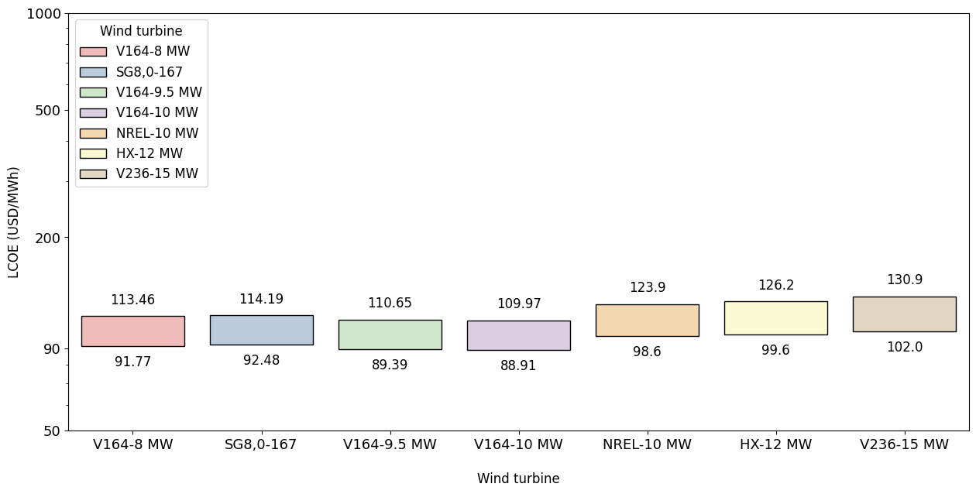
Figure 3. Offshore wind farm LCOE for Area 1.

Table 4 displays the LCOE values illustrated in Figure 3. It also provides the standard deviation, confidence interval, and mean of the LCOE values obtained for each wind turbine in Area 1. Notably, the confidence interval is set at 90% for all values, while the standard deviation generally ranges between 6% and 8%.

Table 4. LCOE values and statistical parameters for Area 1.
Wind  turbine | Lower limit | LCOE (USD/MWh) | Upper limit | Standard deviation | Standard deviation (%) | Confidence interval (%) | Confidence  interval | Mean
15 MW | 102,00 | 124,37 | 130,90 | 8,76 | 7,55% | 90% | ±0,14 | 116,06
9,5 MW | 89,39 | 107,00 | 110,65 | 6,44 | 6,44% | 90% | ±0,11 | 99,85
V10 MW | 88,91 | 106,38 | 109,97 | 6,41 | 6,46% | 90% | ±0,11 | 99,15
V8 MW | 91,77 | 109,67 | 113,46 | 6,49 | 6,34% | 90% | ±0,11 | 102,35
SG 8 MW | 92,48 | 110,50 | 114,19 | 6,62 | 6,42% | 90% | ±0,11 | 103,12
H12 MW | 99,60 | 120,78 | 126,20 | 8,12 | 7,20% | 90% | ±0,13 | 112,71
N 10 MW | 98,60 | 118,92 | 123,90 | 7,72 | 6,96% | 90% | ±0,13 | 110,98

Continuing the analysis of the results, the costs associated with an offshore wind farm installed in Area 2 are presented below. Figure 4 illustrates the levelized cost ranges for Area 2. It can be observed that the lowest range is achieved when the V164-10 MW wind turbine is used - this follows the same cost trend as Area 1, but with a slight increase due to the greater distance from the coast that Area 2 presents.

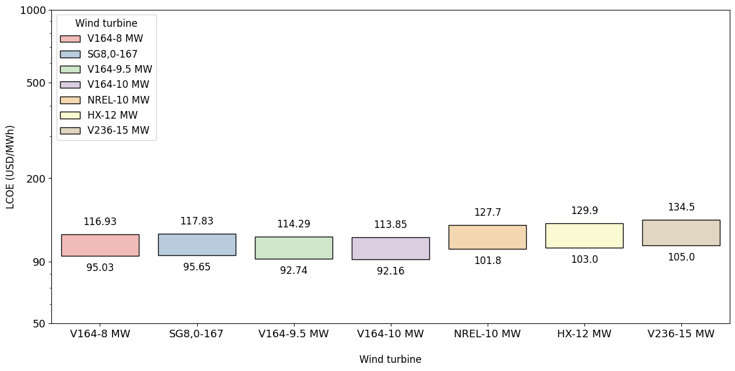
Figure 4. Offshore wind farm LCOE for Area 2.

Table 5 displays the LCOE values illustrated in Figure 4. It also provides the standard deviation, confidence interval, and mean of the LCOE values obtained for each wind turbine in Area 2. Notably, the confidence interval is set at 90% for all values, while the standard deviation generally ranges from 6% to 8%.

Table 5. LCOE values and statistical parameters for Area 2.
Wind  turbine | Lower limit | LCOE (USD/MWh) | Upper limit | Standard deviation | Standard deviation (%) | Confidence interval (%) | Confidence  interval | Mean
15 MW | 105,00 | 128,12 | 134,50 | 8,84 | 7,39% | 90% | ±0,15 | 119,56
9,5 MW | 92,74 | 110,75 | 114,29 | 6,55 | 6,34% | 90% | ±0,11 | 103,35
V10 MW | 92,16 | 110,14 | 113,85 | 6,55 | 6,37% | 90% | ±0,11 | 102,78
V8 MW | 95,03 | 113,43 | 116,93 | 6,63 | 6,26% | 90% | ±0,11 | 105,85
SG 8 MW | 95,65 | 114,25 | 117,83 | 6,69 | 6,28% | 90% | ±0,11 | 106,62
H12 MW | 103,00 | 124,53 | 129,90 | 8,19 | 7,10% | 90% | ±0,14 | 116,21
N 10 MW | 101,80 | 122,68 | 127,70 | 7,87 | 6,87% | 90% | ±0,13 | 114,49

In Figure 5, the levelized cost range of offshore wind energy for the two areas of analysis is displayed. The chart also includes the worldwide levelized cost range of offshore wind energy, as well as those for land-based renewable technologies, such as wind and solar energy, based on the publication by IRENA [5]. Additionally, the levelized cost range of various fossil fuel generation sources is provided, based on the International Energy Agency (IEA) publication [52].

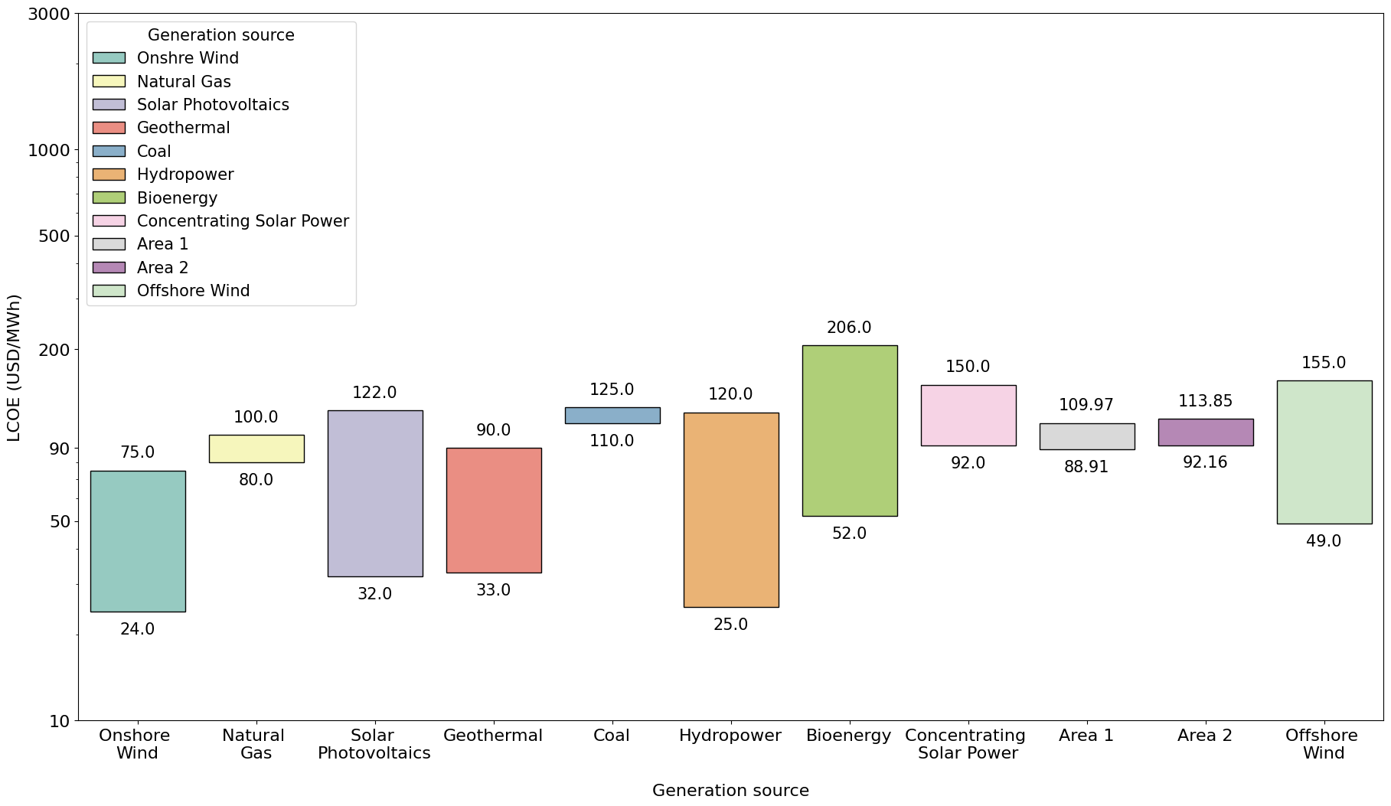
Figure 5. Levelized energy costs from several generation sources. [5],[52].

Figure 5 illustrates that onshore wind energy and hydroelectric plants have the lowest levelized costs worldwide. Onshore solar energy, geothermal plants, bioenergy, and offshore wind follow. The levelized costs of offshore wind energy worldwide are moderately competitive with those of onshore wind and solar energy. Furthermore, the levelized costs associated with the areas of interest are within the range of costs registered worldwide. This similarity presents a favorable opportunity to implement this technology and propose ideas that contribute to the viability of investment in these projects within the Colombian maritime territory.

- Conclusions and recommendations
The review of the current methodologies for estimating costs associated with fixed-foundation offshore wind farms revealed that some proposed mathematical expressions produce results that deviate significantly from global cost trends. In some instances, these expressions even yield negative costs, which is clearly an error. Furthermore, the publications often lack clarity regarding the units in which the input parameters of these mathematical expressions should be presented. This ambiguity leads to calculation errors and outliers, as illustrated in Table 2, which provides a comparative analysis of the mathematical expressions proposed by various authors.
It is worth noting that most references do not provide in-depth coverage of the three key components of capital expenditures for fixed foundation offshore wind projects. Notably, the electrical system is often addressed with the least amount of detail in many publications. This research aims to present a comprehensive methodology that outlines the costs associated with such projects. It describes the mathematical expressions used, details the input parameters' units, and specifies the units of the results. An international currency is employed in alignment with the currency used in publications by organizations dedicated to the study of renewable energy worldwide. Additionally, it estimates a degree of reliability, suggesting that the results obtained will align with global trends.
Based on contributions from the Colombian Ministry of Mines and Energy regarding exploitable wind potential and suitable areas for the implementation of generation facilities in the Colombian Caribbean Sea, along with various mathematical expressions and methodologies found in the literature for estimating costs associated with fixed foundation offshore wind farms, a positive preliminary overview of offshore wind project costs in Colombia was obtained. The analysis particularly focused on areas with the most significant potential. It was observed that capital costs range between USD 3,400 and USD 4,200 per kW, while the levelized energy costs fall between 88 and 131 USD per MWh. These figures align with global averages, and even without optimizing specific parameters or considering ongoing technological advancements, the costs are slightly competitive with both renewable and non-renewable energy sources.
Assuming high wake losses in the range of 10%, a capacity factor greater than 54% was achieved for the 50th percentile. This figure exceeds the globally recorded range of 33% to 50%. It is important to note that optimizing wake losses to the recommended levels discussed in some existing projects, which are below 10%, would enhance the capacity factor and consequently reduce energy production costs at the offshore wind farm.
When considering the costs associated with delivering energy to the coast, it is essential to also consider the expenses related to transporting energy to its destination and its usage on land. In this context, the electrical infrastructure projects being developed in the La Guajira department of Colombia should be considered, particularly the Colectora project in the municipality of Uribia. This project could have a direct impact on the levelized cost of energy, as transmission infrastructure from the coast to the rest of the country is under construction. The possibility of connecting energy from the proposed offshore wind farm should therefore be explored. Despite the current situation, which involves delivering energy just one kilometer from the coast, and the absence of a cost analysis at the 90th percentile, the outlook for developing such projects in Colombia remains promising.
This study primarily contributes a comprehensive methodology for determining the CAPEX, OPEX, and LCOE for fixed foundation offshore wind projects. It includes a review and critical analysis of various methods proposed in publications worldwide for calculating the costs of these projects. Additionally, the study provides a preliminary positive overview of the costs associated with adopting fixed foundation wind technology in the Colombian Caribbean Sea, emphasizing the areas with the most significant potential as identified by the Ministry of Mines and Energy of Colombia. Based on these insights, new research ideas are proposed, focusing on other aspects of implementing an offshore wind farm in Colombia. These include considerations for floating structure installations, optimization of technical losses related to wind farm operations, necessary administrative expenses, and enhancements to cost calculation models based on existing methodologies and the approach proposed in this research.

- Declaration of competing interests
The authors declare that they have no known competing financial interests or personal relationships that could have appeared to influence the work reported in this paper.

- Funding
The author(s) received no financial support for the research, authorship, and/or publication of this article.

- Author contributions
J. M. Illidge-Araujo: Conceptualization. J. Illidge, C. Barrios; Formal analysis: J. Illidge, M. Martinez: Methodology,

J. M. Illidge-Araujo. J. L. Chacón-Velasco. J. M. Illidge-Araujo: Investigation , Data curation and Writing-original draft preparation and visualization

All authors have read and agreed to the published version of the manuscript.

- Data availability statement
The authors confirm that the data supporting the findings of this study are available within the article and its supplementary materials.

References
[1] Ministerio de Minas y Energía, Renewables Consulting Group, and World Bank Group, “Hoja de ruta para el despliegue de la energía eólica costa afuera en Colombia,” Ministerio de minas y energía, Colombia, Reporte Final, 2022. [Online]. Available: https://www.minenergia.gov.co/es/micrositios/enlace-ruta-eolica-offshore/
[2] IRENA, “Renewable energy statistics 2025.” Accessed: Aug. 28, 2025. [Online]. Available: https://www.irena.org/Publications/2025/Jul/Renewable-energy-statistics-2025
[3] R. Hall, E. João, and C. W. Knapp, “Environmental impacts of decommissioning: Onshore versus offshore wind farms,” Environ. Impact Assess. Rev., vol. 83, p. 106404, July 2020, doi: 10.1016/j.eiar.2020.106404.
[4] A. G. Gonzalez-Rodriguez, J. Serrano-Gonzalez, M. Burgos-Payan, and J. Riquelme-Santos, “Multi-objective optimization of a uniformly distributed offshore wind farm considering both economic factors and visual impact,” Sustain. Energy Technol. Assess., vol. 52, p. 102148, Aug. 2022, doi: 10.1016/j.seta.2022.102148.
[5] IRENA, “Renewable Power Generation Costs in 2024.” Accessed: Aug. 28, 2025. [Online]. Available: https://www.irena.org/Publications/2025/Jun/Renewable-Power-Generation-Costs-in-2024
[6] T. Stehly, P. Duffy, and D. M. Hernando, “Cost of Wind Energy Review: 2024 Edition,” 2024.
[7] Y. Liang, Y. Ma, H. Wang, A. Mesbahi, B. Jeong, and P. Zhou, “Levelised cost of energy analysis for offshore wind farms – A case study of the New York State development,” Ocean Eng., vol. 239, p. 109923, Nov. 2021, doi: 10.1016/j.oceaneng.2021.109923.
[8] J. Sim, “An economic evaluation of potential offshore wind farm sites in South Korea using a real options approach,” Energy Rep., vol. 10, pp. 29–37, Nov. 2023, doi: 10.1016/j.egyr.2023.06.007.
[9] S. Alsubal, W. S. Alaloul, E. L. Shawn, M. S. Liew, P. Palaniappan, and M. A. Musarat, “Life Cycle Cost Assessment of Offshore Wind Farm: Kudat Malaysia Case,” Sustainability, vol. 13, no. 14, Art. no. 14, Jan. 2021, doi: 10.3390/su13147943.
[10] U. Cali, N. Erdogan, S. Kucuksari, and M. Argin, “Techno-economic analysis of high potential offshore wind farm locations in Turkey,” Energy Strategy Rev., vol. 22, pp. 325–336, Nov. 2018, doi: 10.1016/j.esr.2018.10.007.
[11] M. M. Lozer dos Reis, B. Mitsuo Mazetto, and E. Costa Malateaux da Silva, “Economic analysis for implantation of an offshore wind farm in the Brazilian coast,” Sustain. Energy Technol. Assess., vol. 43, p. 100955, Feb. 2021, doi: 10.1016/j.seta.2020.100955.
[12] J. Y. Ozato, G. Aquila, E. de Oliveira Pamplona, L. C. S. Rocha, and P. Rotella Junior, “Offshore wind power generation: An economic analysis on the Brazilian coast from the stochastic LCOE,” Ocean Coast. Manag., vol. 244, p. 106835, Oct. 2023, doi: 10.1016/j.ocecoaman.2023.106835.
[13] World Bank Group, “Colombia Offshore Wind Workshops,” 2023.
[14] L. F. García-Rodríguez, J. E. Jaramillo, and J. L. C. Velasco, “Chicamocha canyon wind energy potential and VAWT airfoil selection through CFD modeling,” Rev. Fac. Ing. Univ. Antioquia, no. 94, Art. no. 94, Oct. 2020, doi: 10.17533/udea.redin.20190512.
[15] J. D. Rosero-Ariza, J. L. Chacón-Velasco, and G. González-Silva, “Comparative CFD analysis of six VAWT turbines in the Chicamocha Canyon,” Rev. Fac. Ing. Univ. Antioquia, no. 113, pp. 58–70, Apr. 2024, doi: 10.17533/udea.redin.20240413.
[16] E. C. Marques, V. de A. Guimarães, M. de Azevedo-Ferreira, and R. A. M. Boloy, “Renewable energy in sustainable supply chain: A review,” Rev. Fac. Ing. Univ. Antioquia, no. 104, pp. 152–167, 2022, doi: 10.17533/udea.redin.20210956.
[17] J. C. Sosapanta-Salas, C. D. Zuluaga-Ríos, S. D. Saldarriaga-Zuluaga, and J. D. Velásquez-Gómez, “Sustainable energy solutions in Colombia based on isolated DC microgrids,” Rev. Fac. Ing. Univ. Antioquia, 2023, doi: 10.17533/udea.redin.20250878.
[18] J. C. P. Ortiz, A. S. Barona, A. Rubio-Clemente, and E. L. C. Arrieta, “Assessment of the Wind Power Potential in the Gulf of Urabá, Department of Antioquia,” Ing. E Investig., vol. 42, no. 3, p. e92351, Feb. 2022, doi: 10.15446/ing.investig.92351.
[19] V. Saxena, N. Kumar, and U. Nangia, “Recent Trends in the Optimization of Renewable Distrib-uted Generation: A Review,” Ing. E Investig., vol. 42, no. 3, p. e97702, Feb. 2022, doi: 10.15446/ing.investig.97702.
[20] J. M. Illidge-Araujo, J. L. Chacon-Velasco, A. J. Chacon-Velasco, and C. Romero-Piehadraita, “Diseño y simulación de un sistema pico-hydro para la generación de energía eléctrica en zonas rurales, mediante un software de mecánica de fluidos computacional,” Rev. UIS Ing., vol. 19, no. 1, Art. no. 1, Jan. 2020, doi: 10.18273/revuin.v19n1-2020015.
[21] J. Mesa-Calle, W. Villa-Acevedo, and J. M. López-Lezama, “Impacto de las fuentes de energía renovable en la estabilidad de la tensión y técnicas de evaluación,” Rev. UIS Ing., vol. 22, no. 3, pp. 151–166, Sept. 2023, doi: 10.18273/revuin.v22n3-2023011.
[22] A. Díaz-Motta, F. Díaz-González, and M. Villa-Arrieta, “Energy sustainability assessment of offshore wind-powered ammonia,” J. Clean. Prod., vol. 420, p. 138419, Sept. 2023, doi: 10.1016/j.jclepro.2023.138419.
[23] R. Chitteth Ramachandran, C. Desmond, F. Judge, J.-J. Serraris, and J. Murphy, “Floating wind turbines: marine operations challenges and opportunities,” Wind Energy Sci., vol. 7, no. 2, pp. 903–924, Apr. 2022, doi: 10.5194/wes-7-903-2022.
[24] A. Martinez and G. Iglesias, “Mapping of the levelised cost of energy for floating offshore wind in the European Atlantic,” Renew. Sustain. Energy Rev., vol. 154, p. 111889, Feb. 2022, doi: 10.1016/j.rser.2021.111889.
[25] M. Kreider, F. Oteri, A. Robertson, C. Constant, and E. Gill, “Offshore Wind Energy: Technology Below the Water,” 2022, [Online]. Available: https://www.nrel.gov/docs/fy22osti/83142.pdf
[26] S. Santhakumar, G. Smart, M. Noonan, H. Meerman, and A. Faaij, “Technological progress observed for fixed-bottom offshore wind in the EU and UK,” Technol. Forecast. Soc. Change, vol. 182, p. 121856, Sept. 2022, doi: 10.1016/j.techfore.2022.121856.
[27] Z. Jiang, “Installation of offshore wind turbines: A technical review,” Renew. Sustain. Energy Rev., vol. 139, p. 110576, Apr. 2021, doi: 10.1016/j.rser.2020.110576.
[28] M. Bilgili and H. Alphan, “Global growth in offshore wind turbine technology,” Clean Technol. Environ. Policy, vol. 24, no. 7, pp. 2215–2227, Sept. 2022, doi: 10.1007/s10098-022-02314-0.
[29] O. S. Ohunakin et al., “Techno-economic assessment of offshore wind energy potential at selected sites in the Gulf of Guinea,” Energy Convers. Manag., vol. 288, p. 117110, July 2023, doi: 10.1016/j.enconman.2023.117110.
[30] M. Bilgili, H. Alphan, and A. Ilhan, “Potential visibility, growth, and technological innovation in offshore wind turbines installed in Europe,” Environ. Sci. Pollut. Res., vol. 30, no. 10, pp. 27208–27226, Feb. 2023, doi: 10.1007/s11356-022-24142-x.
[31] A. Arce Canga-Argüelles, “Análisis del estado del arte de aerogeneradores offshore. Estado de la tecnología, ventajas competitivas, limitaciones y principales fabricantes,” 2021, Accessed: Nov. 25, 2023. [Online]. Available: https://idus.us.es/handle/11441/128922
[32] E. P. P. Soares-Ramos, L. de Oliveira-Assis, R. Sarrias-Mena, and L. M. Fernández-Ramírez, “Current status and future trends of offshore wind power in Europe,” Energy, vol. 202, p. 117787, July 2020, doi: 10.1016/j.energy.2020.117787.
[33] S. A. Gil Ruiz, J. E. C. Barriga, and J. A. Martínez, “Wind power assessment in the Caribbean region of Colombia, using ten-minute wind observations and ERA5 data,” Renew. Energy, vol. 172, pp. 158–176, July 2021, doi: 10.1016/j.renene.2021.03.033.
[34] H. Sun, X. Gao, and H. Yang, “A review of full-scale wind-field measurements of the wind-turbine wake effect and a measurement of the wake-interaction effect,” Renew. Sustain. Energy Rev., vol. 132, p. 110042, Oct. 2020, doi: 10.1016/j.rser.2020.110042.
[35] J. C. Y. Lee and M. J. Fields, “An overview of wind-energy-production prediction bias, losses, and uncertainties,” Wind Energy Sci., vol. 6, no. 2, pp. 311–365, Mar. 2021, doi: 10.5194/wes-6-311-2021.
[36] C.-D. Yue, C.-C. Liu, C.-C. Tu, and T.-H. Lin, “Prediction of Power Generation by Offshore Wind Farms Using Multiple Data Sources,” Energies, vol. 12, no. 4, Art. no. 4, Jan. 2019, doi: 10.3390/en12040700.
[37] H. B. Anangapal, B. Jeyaraj, and K. Victor, “Optimization of India’s offshore wind farm capacity density - a case study,” Environ. Dev. Sustain., Aug. 2024, doi: 10.1007/s10668-024-05278-x.
[38] Q. Vu Dinh, Q.-V. Doan, T. Ngo-Duc, V. Nguyen Dinh, and N. Dinh Duc, “Offshore wind resource in the context of global climate change over a tropical area,” Appl. Energy, vol. 308, p. 118369, Feb. 2022, doi: 10.1016/j.apenergy.2021.118369.
[39] R. P. Patel, G. Nagababu, S. S. Kachhwaha, and V. V. A. K. Surisetty, “A revised offshore wind resource assessment and site selection along the Indian coast using ERA5 near-hub-height wind products,” Ocean Eng., vol. 254, p. 111341, June 2022, doi: 10.1016/j.oceaneng.2022.111341.
[40] M. Dicorato, G. Forte, M. Pisani, and M. Trovato, “Guidelines for assessment of investment cost for offshore wind generation,” Renew. Energy, vol. 36, no. 8, pp. 2043–2051, Aug. 2011, doi: 10.1016/j.renene.2011.01.003.
[41] A. Yildirim, “The technical and economical feasibility study of offshore wind farms in Turkey,” Clean Technol. Environ. Policy, vol. 25, no. 1, pp. 125–142, Jan. 2023, doi: 10.1007/s10098-022-02392-0.
[42] M. Shafiee, F. Brennan, and I. A. Espinosa, “A parametric whole life cost model for offshore wind farms,” Int. J. Life Cycle Assess., vol. 21, no. 7, pp. 961–975, July 2016, doi: 10.1007/s11367-016-1075-z.
[43] T. Stehly and P. Duffy, “2021 Cost of Wind Energy Review”.
[44] T. Stehly, P. Duffy, and D. M. Hernando, “2022 Cost of Wind Energy Review,” 2022, [Online]. Available: https://www.nrel.gov/docs/fy24osti/88335.pdf
[45] F. Tilca, J. F. M. Malvasio, and C. Placco, “Valores sugeridos de pérdidas e incertidumbres en el cálculo de probabilidades de excedencia de parques eólicos.,” Energ. Renov. Medio Ambiente, vol. 48, pp. 47–56, 2021.
[46] “Renewables 2024 – Analysis,” IEA. Accessed: Dec. 03, 2024. [Online]. Available: https://www.iea.org/reports/renewables-2024
[47] A. Wędzik, M. Szypowski, and T. Siewierski, “An integrated method to simultaneously optimise a wind farm’s internal network layout, cable cross-sections and substation location,” Appl. Energy, vol. 377, p. 124361, Jan. 2025, doi: 10.1016/j.apenergy.2024.124361.
[48] M. Ye, H.-C. Chen, and A. Koop, “High-fidelity CFD simulations for the wake characteristics of the NTNU BT1 wind turbine,” Energy, vol. 265, p. 126285, Feb. 2023, doi: 10.1016/j.energy.2022.126285.
[49] Z. Jiang, “Installation of offshore wind turbines: A technical review,” Renew. Sustain. Energy Rev., vol. 139, p. 110576, Apr. 2021, doi: 10.1016/j.rser.2020.110576.
[50] IEA, “World Energy Outlook 2024 – Analysis,” IEA. Accessed: July 25, 2025. [Online]. Available: https://www.iea.org/reports/world-energy-outlook-2024
[51] E. B. Mora, J. Spelling, A. H. van der Weijde, and E.-M. Pavageau, “The effects of mean wind speed uncertainty on project finance debt sizing for offshore wind farms,” Appl. Energy, vol. 252, p. 113419, Oct. 2019, doi: 10.1016/j.apenergy.2019.113419.
[52] IEA, “Projected Costs of Generating Electricity 2020 – Analysis,” IEA. Accessed: Jan. 02, 2024. [Online]. Available: https://www.iea.org/reports/projected-costs-of-generating-electricity-2020

