
How to do a review?

Journal System-UdeA

- Go to the right side of the upper banner and select the Login tab, where you must enter your username and password. In case you do not have an account, select the Register tab and follow the instructions.

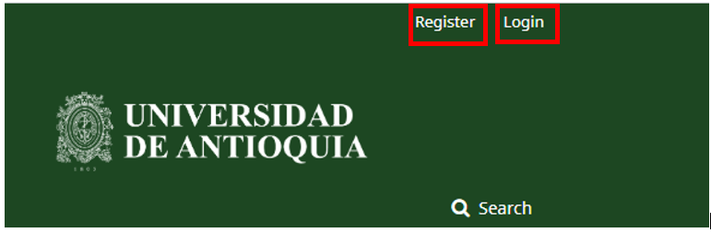

- In My Queue tab you will find the list of the manuscripts that have been assigned to you to review and the deadlines to respond to the editor and carry out the review. Click on the name of the paper to view the article metadata and to find the option to accept or reject reviewing.

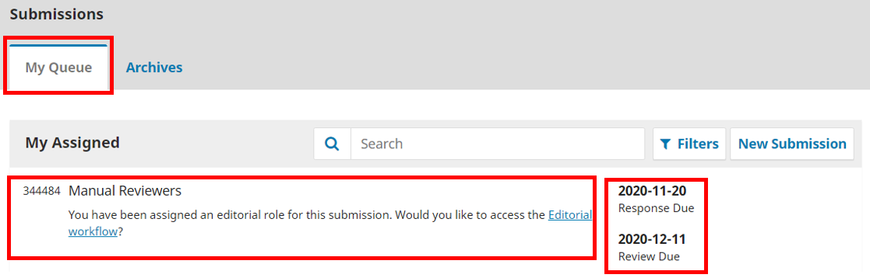

2.1. A new window opens in which you can find information about the article and the request made, such as the title and type of review.

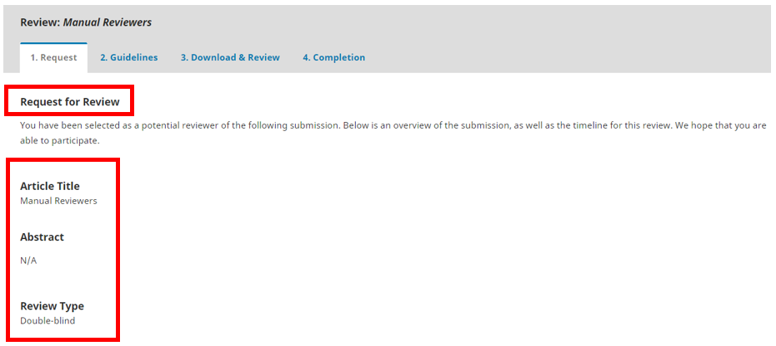

2.2. In Review Files, click on the name of the paper to get access to it. If you want to see some details of the article before accessing it, you can click View All Submission Details. You will also find information about the due dates for you to take into account (click About Due Dates).
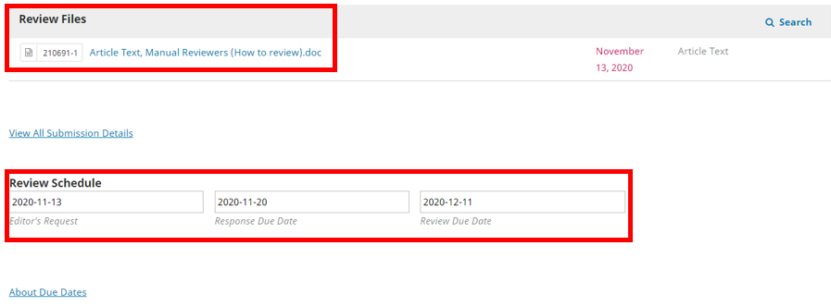

2.3. Declare whether or not you have competing interests (conflicts of interest) and indicate whether or not you will do the review by clicking the Accept Review or Decline Review Request tab.

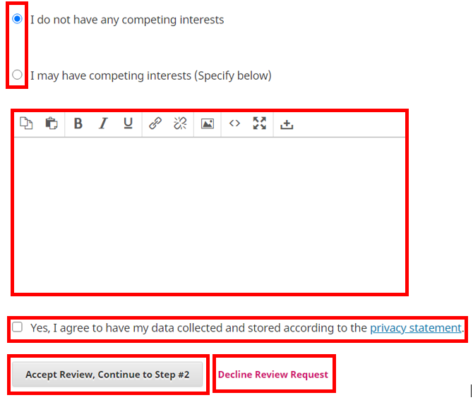

- The guidelines on the evaluation process are in step two. Read carefully and press the option Continue to Step # 3.

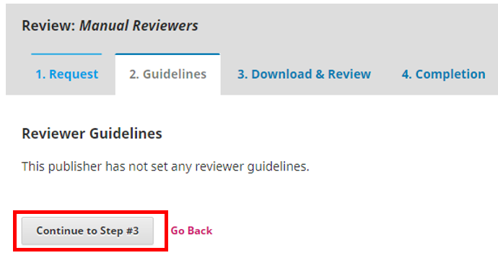

- Fill in the criteria established in the Evaluation Form provided by the journal to review the paper. Example:
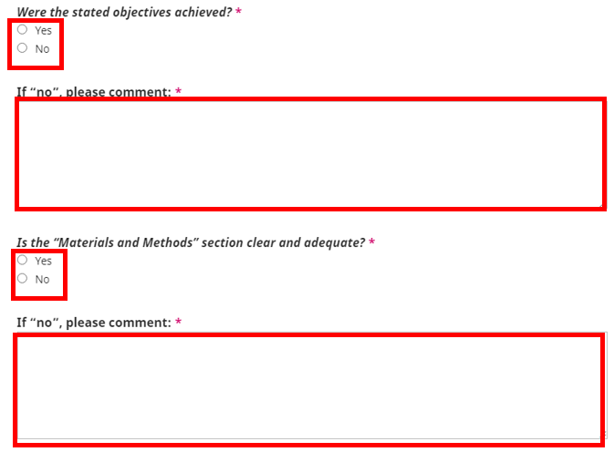

4.1. In case you want to attach the article with your comments -or another document- press the Upload File option. To send an email to the editor select the Add discussion tab. Finally, select your recommendation to the editor and press the Submit Request button.
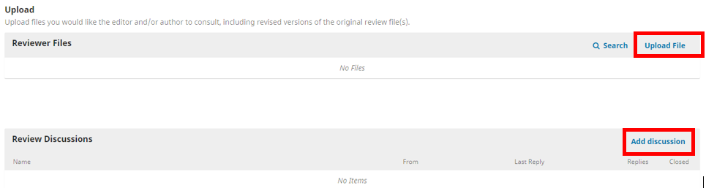
- Finally, the system will show you a confirmation message.
